

**CP5047**

**ICT 1: Analysis and Design**

**Submitted by Team11.**

**PROJECT DOCUMENTATION**

**Table of Contents**

1. **Team members and their contribution ………………3**
2. **Project Description (Non-ICT) …………………………3**
3. **Client Side**
4. Client’s Confirmation Email **………………………………7**
5. Client Agreement……………………………………………8
6. Client’s Requirement…………………………...14
   * 1. Mini Alpha Release……………………...15
     2. Beta Release…………………………….17
     3. Final Release…………………………….17
7. **Project Development and ICT Infrastructure……………17**
   1. Configuration Management / Version Control...17
   2. Project Tools…………….………………………18
   3. Testing…………………………………………...18
8. **Layout………………………………………………………….19**
   1. Flowchart of Website……………………………………20
   2. Layout 1: Homepage……………………………………20
   3. Layout 2: Query Form………………………………….20
9. **Prototype** ……………………………………………………………….21
   1. Homepage……………………………………………….21
   2. Using dreamweaver ……………………………………22
   3. What we deliver webpage……………………………….23
   4. Hospitality webpage ……………………………………24

**PROJECT DOCUMENTATION**

# TEAM MEMBERS

|  |  |  |
| --- | --- | --- |
| Sr. No. | Name of Student | Contribution |
| 1 | Shivali Pradhan | Setting Task priorities, Research on Simulation tools, Time allocation, Project Design, Project Development, Client Coordination, Client agreement. |
| 2 | Jinal Patel | Project Audit, Client agreement, Project Development, Market Research. |
| 3 | Gurmanpreet Singh Sidhu | Market Research, Project Analysis and testing, Minutes of meeting. |

# PROJECT DESCRIPTION (NON-ICT)

This project is about designing a mobile app, it is based on the idea of business through Whats app and Instagram platforms. These business do not have any organised platform for their customers. For example, there is an whats app group in which the admin sends images of all the products and then the user asks the price and sometime they send direct message to admin on personal chats, in most of the groups the admin have more than 20 customers sometime even more. So we provide our clients with an app in which we integrate a system where all his customers can access the product information and can place order and also the customer can see other business and can send request to join these groups.

Our work here is to build an app that helps our client to organise their business. For growing business, it is very crucial that they provide good service and sustain their customer, if they are not able to do it the customer might no return. This app provides these customers a better platform to know the business and to be a long-time customer.

We found an opportunity to facilitate a solution which is suitable for their business.

Website is platform to showcase the client’s work. By including profile, gallery or videos we can demonstrate how the companies’ services stands out from their competitors. Thus, a professionally designed website will be the best ICT solution for our client.

**Project requirements**

**Mini-Alpha**

1. **Webpage:**
2. **Homepage** - must be attractive and must mesmerize the customer. Display all product and prices.
3. **Responsive**: website must be responsive so that can be accessible in all devices of any width.
4. **Cart and checkout**: Includes cart page and checkout.
5. **Domain Name**: Need to purchase a domain name for website.

After discussing with the client, we did research on similar websites. Search on website with similar content. Collected all the required database for website (images products, decide content to be written) and designed the website using a template(venezo).

Considering these requirement, we have planned our mini- alpha release. Our alpha release will be released within 18 days. We are 3 members in our team and we work 2 days a week for 3 weeks to release alpha. So available days are 3*2*3=18 days.

**Alpha Release:**

|  |  |  |  |  |  |
| --- | --- | --- | --- | --- | --- |
| **Release** | **SN** | **User Story** | **Description** | **Priority** | **Status** |
| **MINI Alfa ICT2-3 Weeks** | 1 | Homepage | Product display | 10 | completed |
| 2 | Measurement Form | Stitching measurement | 20 | completed |
| 3 | Cart | Product added | 10 | completed |
| 4 | Checkout | Form for card and shipping and customer details | 10 | in progress |
| 5 | Database | All Product details and card and customer details being stored. | 20 | in progress |

**Beta Release:**

**1.App Design:**

* 1. **Layout** - must be attractive and must mesmerize the customer. Include picture which urge their desire for destination wedding.
  2. **Database**: website must be responsive so that can be accessible in all devices of any width.

|  |  |  |  |  |  |
| --- | --- | --- | --- | --- | --- |
| **Beta ICT2 5 weeks** | 1 | Admin Page | Customer Login as well as client login to make page dynamic. | 10 | in progress |
| 2 | App Design | Layout for app | 10 | in progress |
| 3 | Database | Database integrated with app. | 20 | in progress |

**Final Release:**

|  |  |  |  |  |  |
| --- | --- | --- | --- | --- | --- |
| **Final ICT2** | 1 | Testing (Database) | All information is received and stored. | 30 | in progress |
| 2 | Testing (server) | Make website and app live on server. | 30 | in progress |
| 3 | Bug Fix | Fix all bugs or error | 40 | in progress |

**Client’s Confirmation Email:**

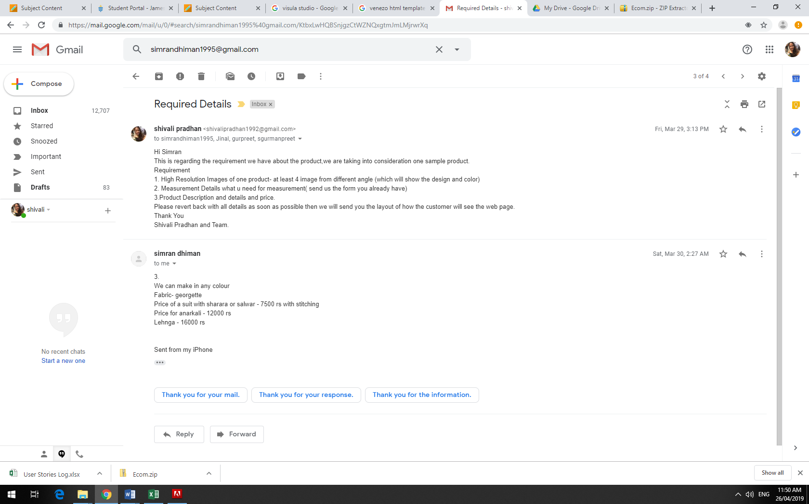

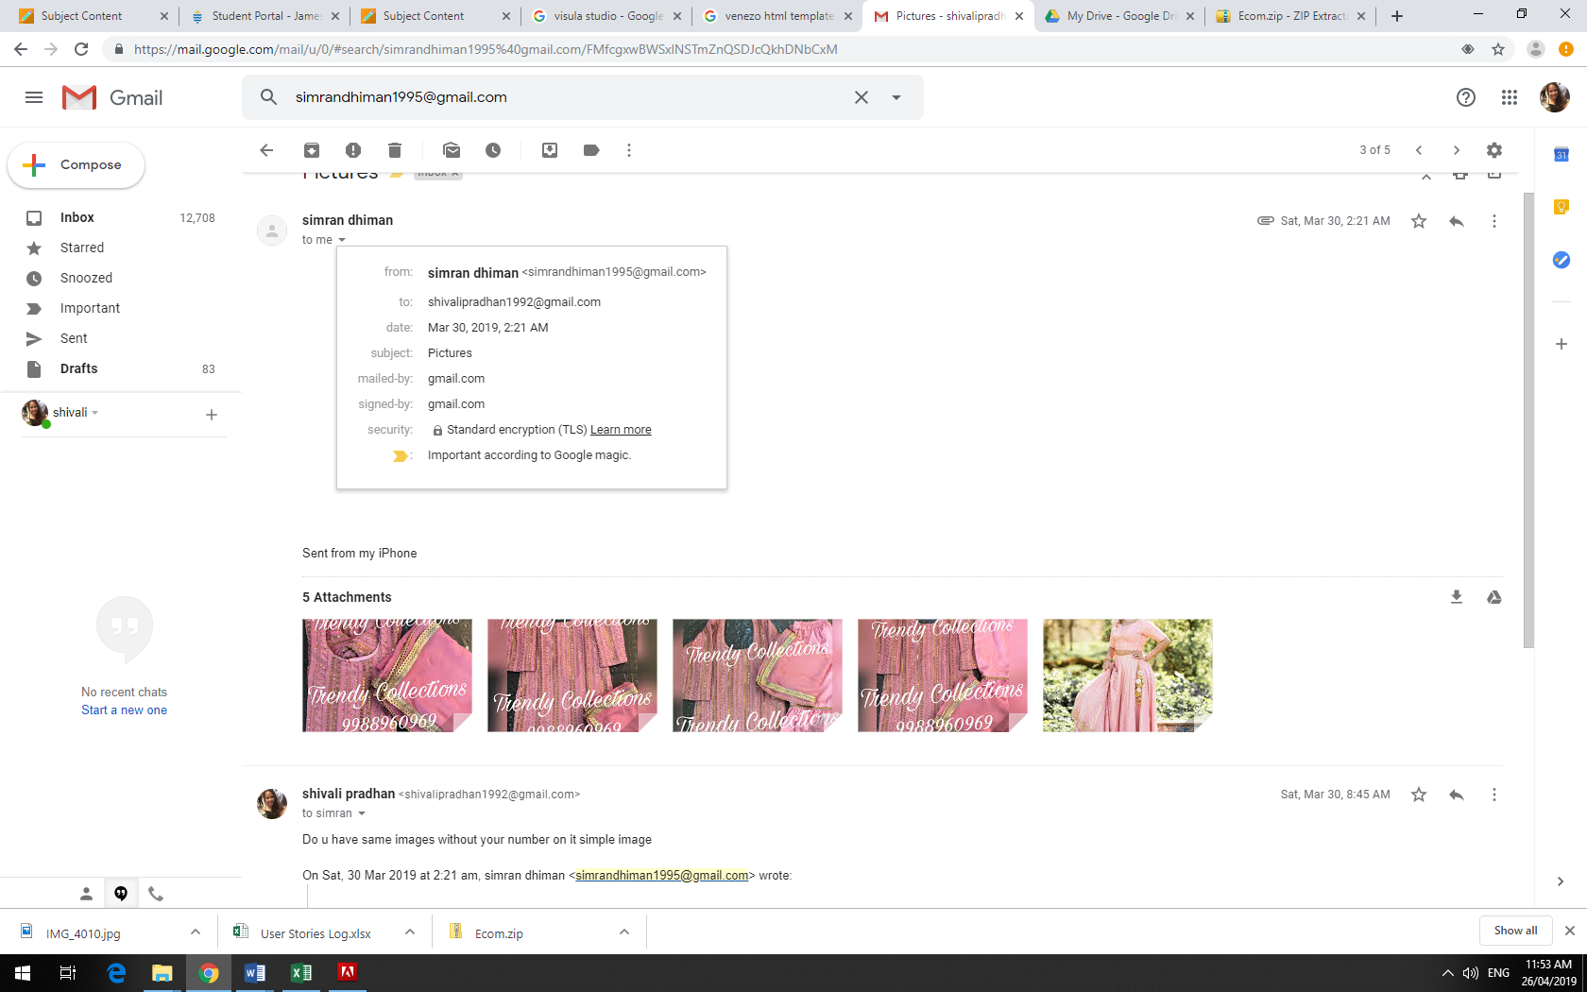 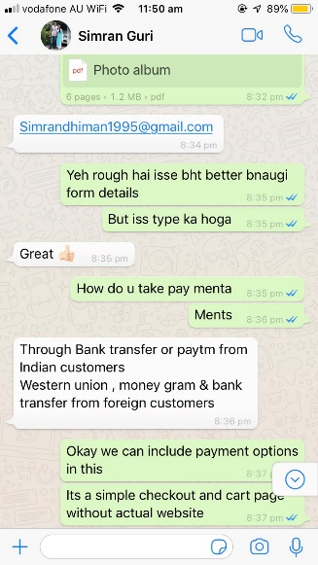 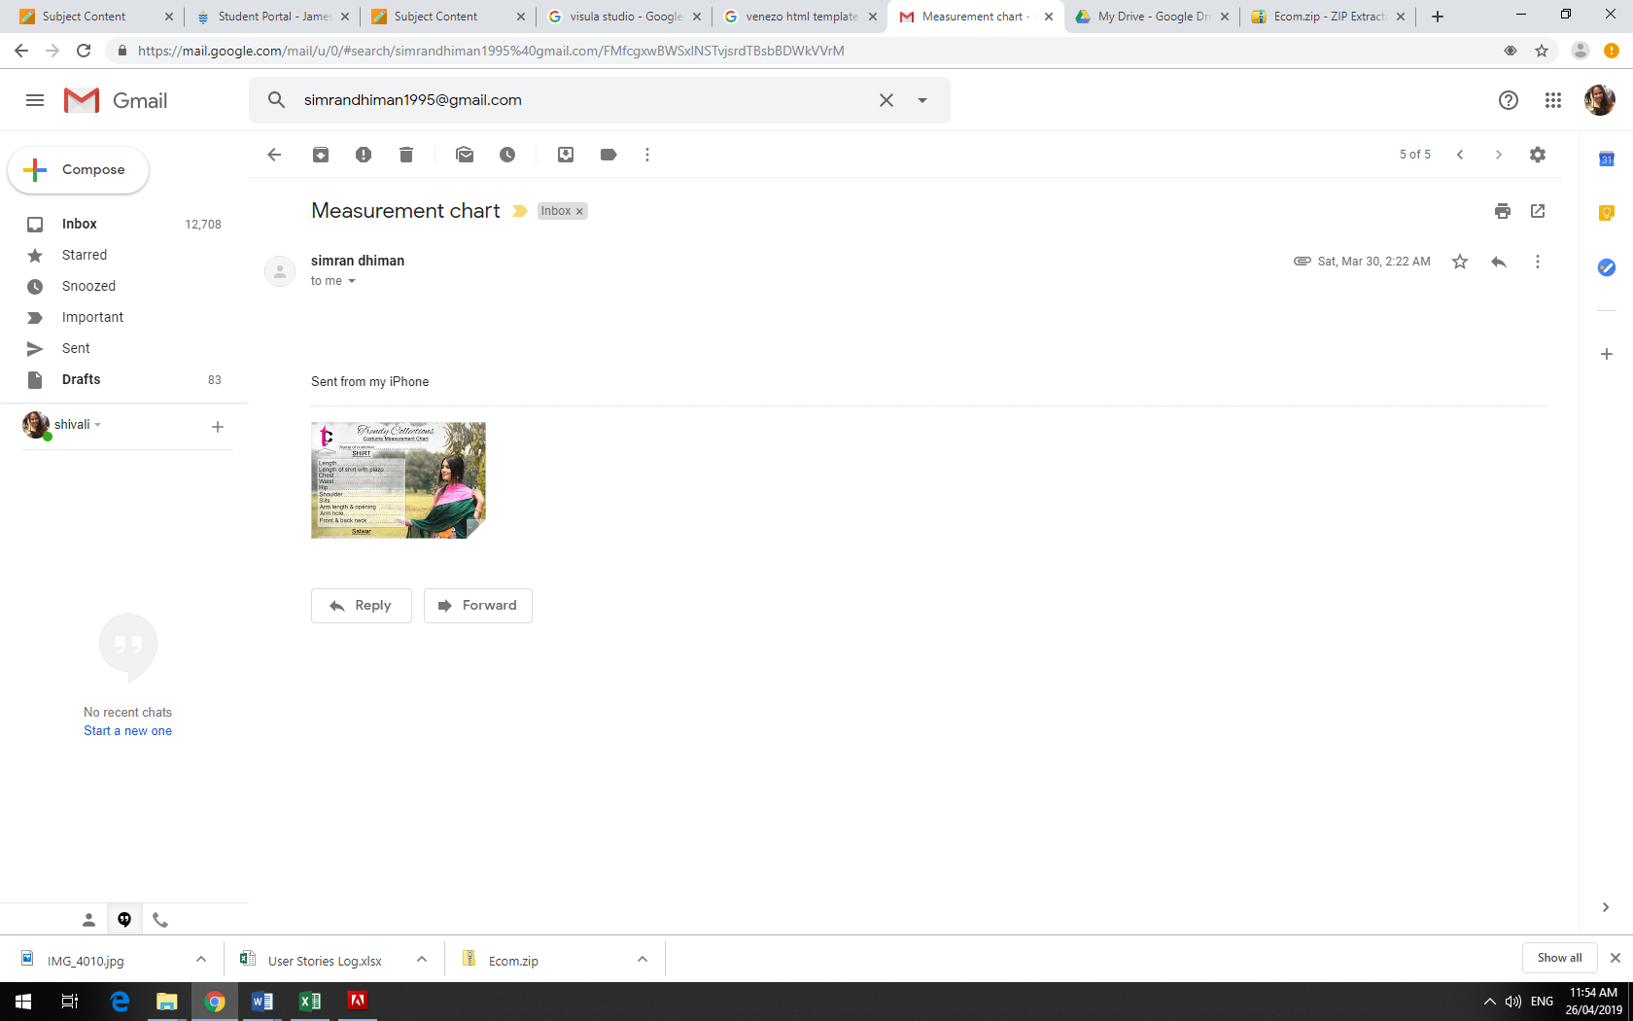

**Project Agreement:**

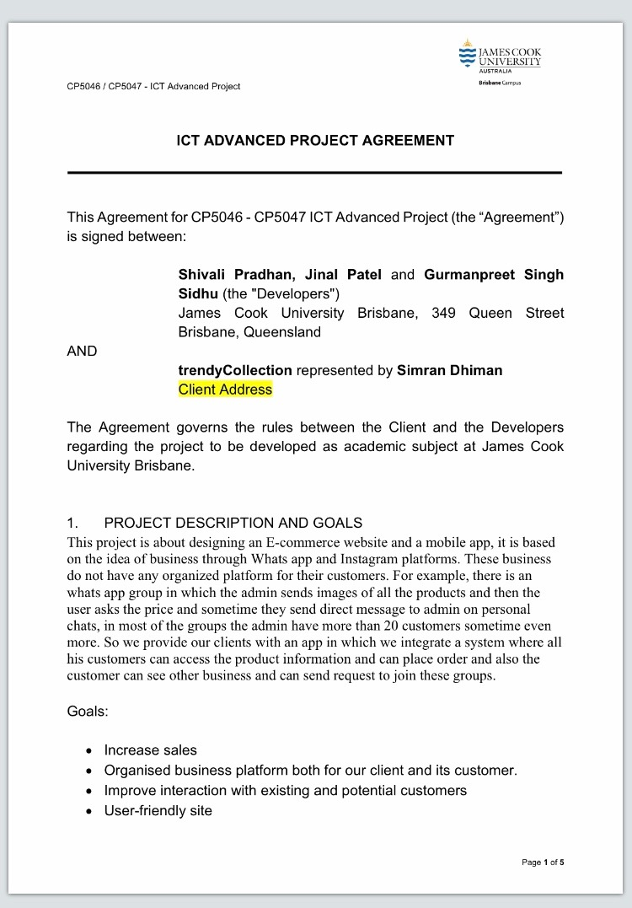

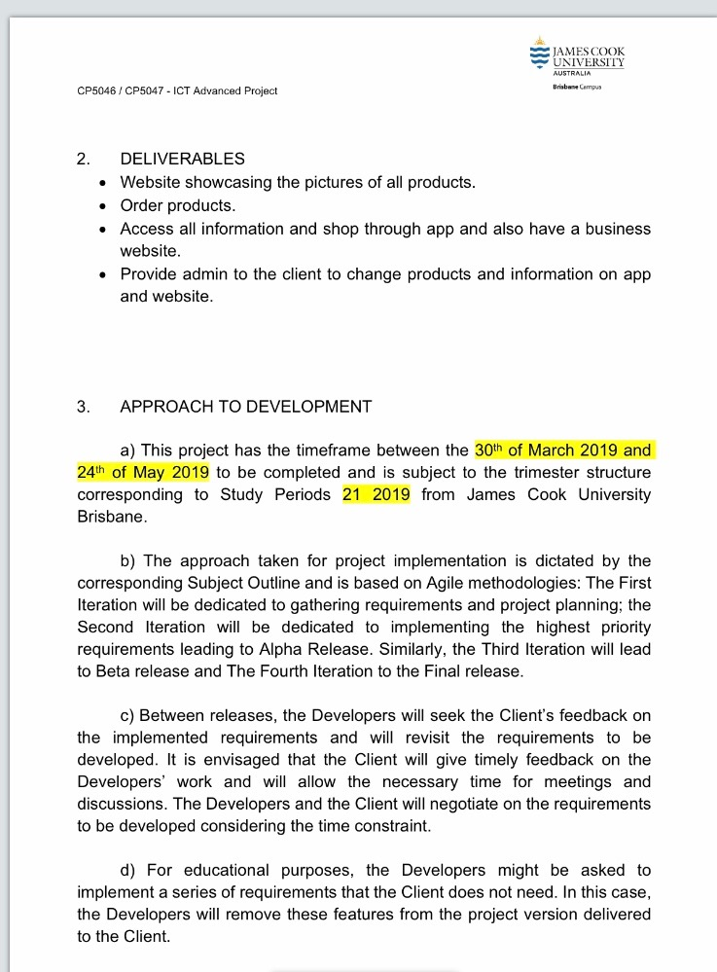

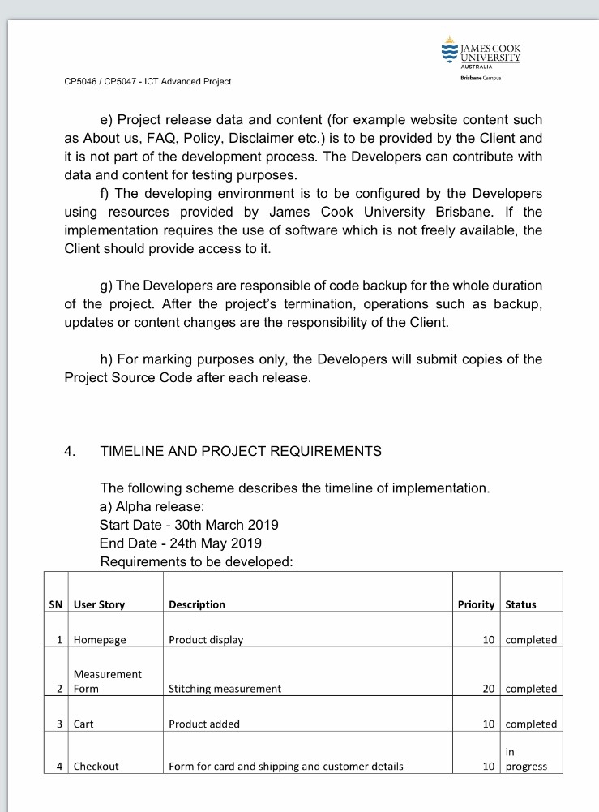

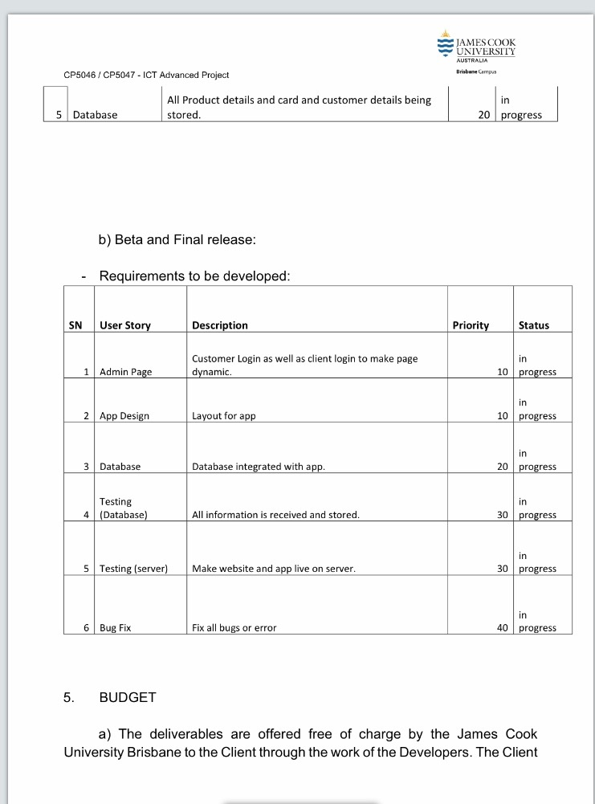

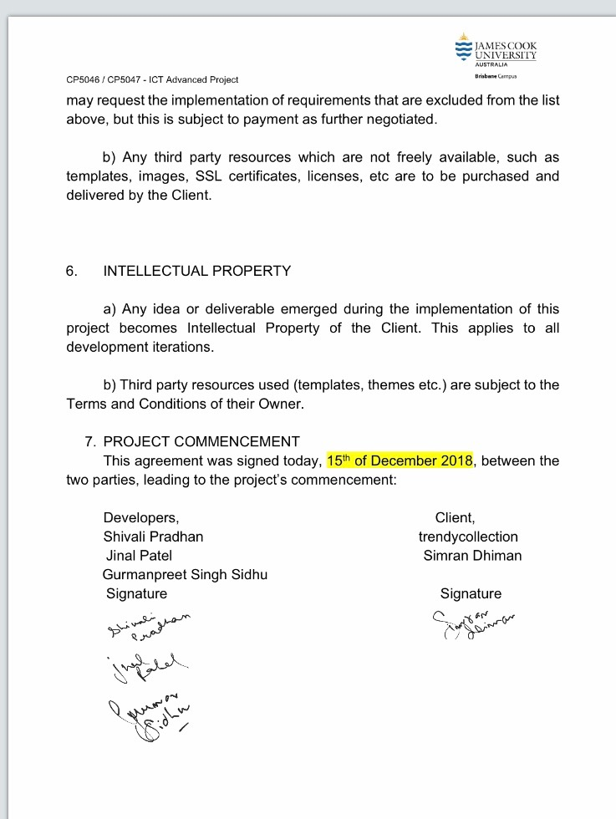

**Burn Down Chart for Mini-Alpha.**

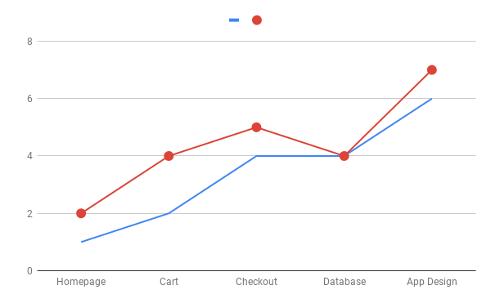

Preparation for Final Release

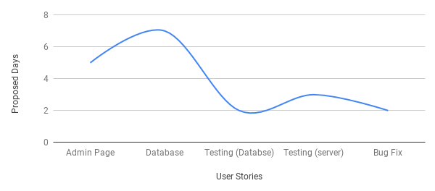

**Project Developments**

* **Development environment**: Visual studio and Android studio.
* **Programming languages:** .net, MySQL for the database
* **Source code repositories** (Configuration Management): GitHub,
* **Project collaboration tools**: Hosting server (still pending), Android Play Store for app.

**Homepage Screenshot**

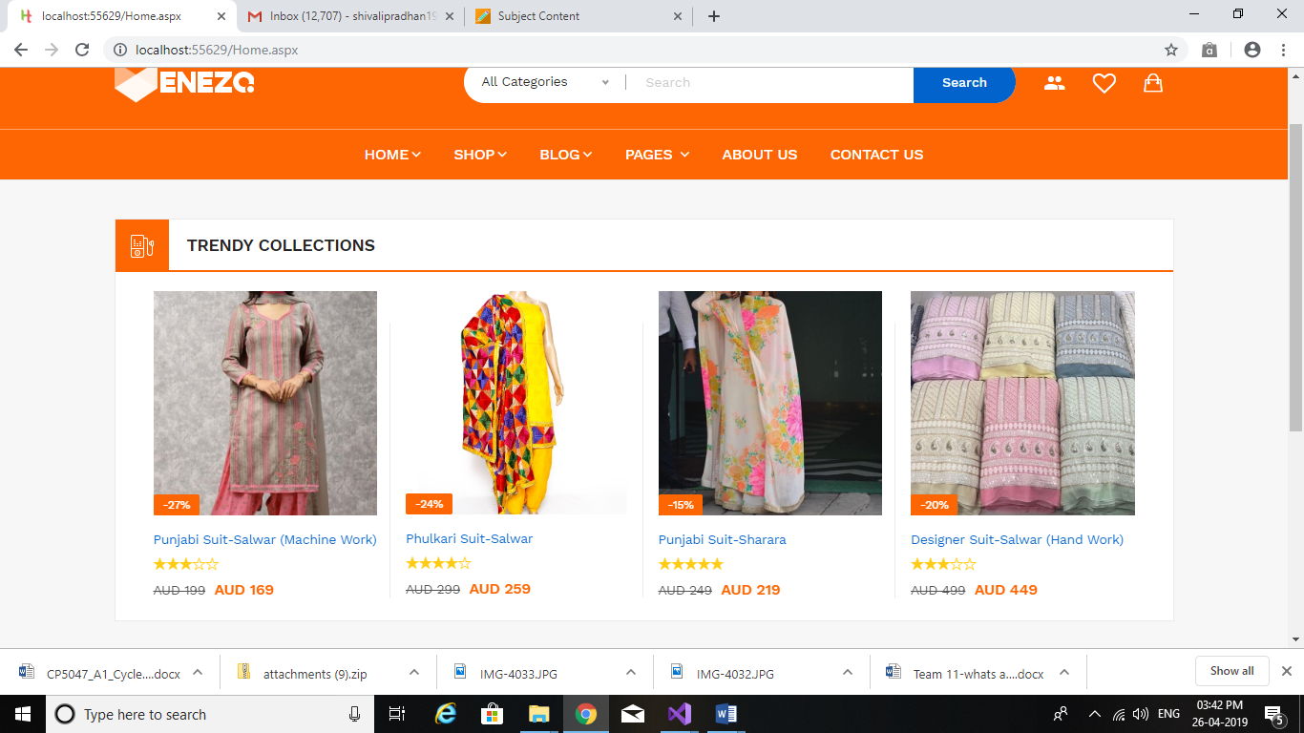

**Cart**

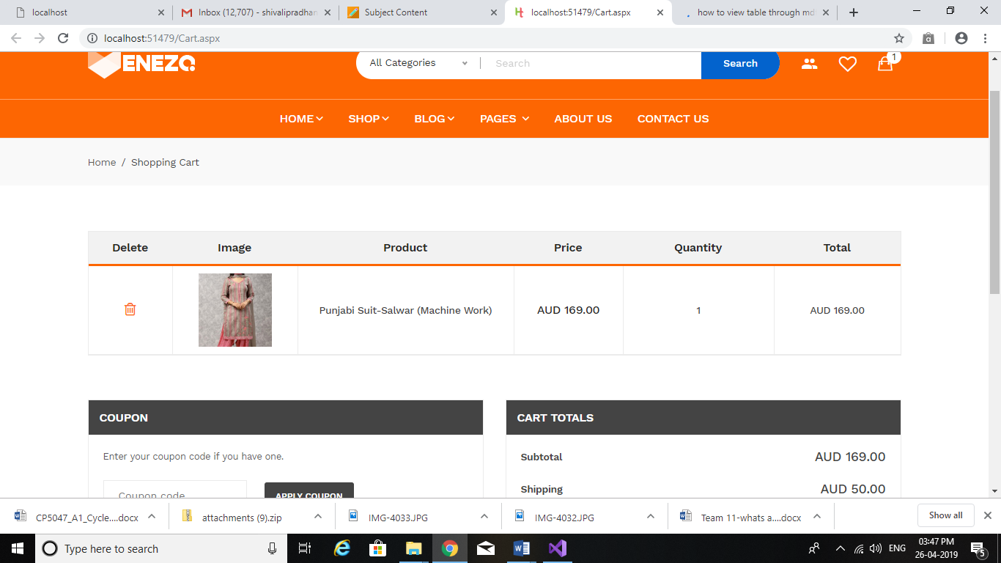

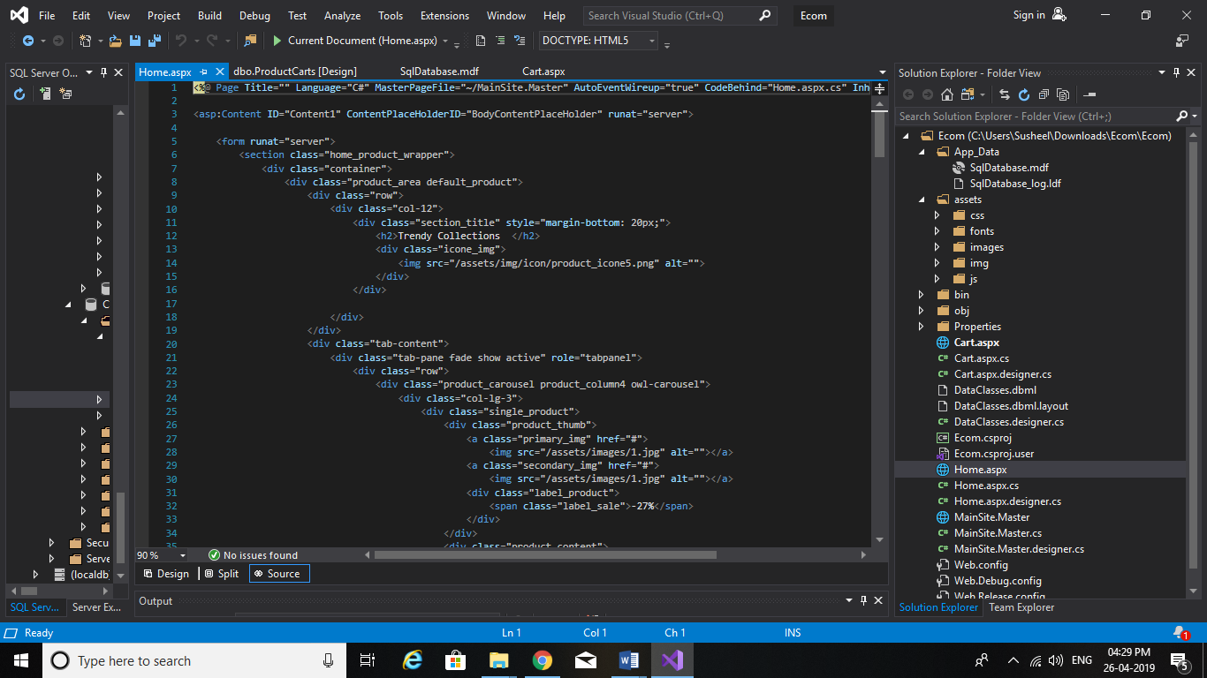

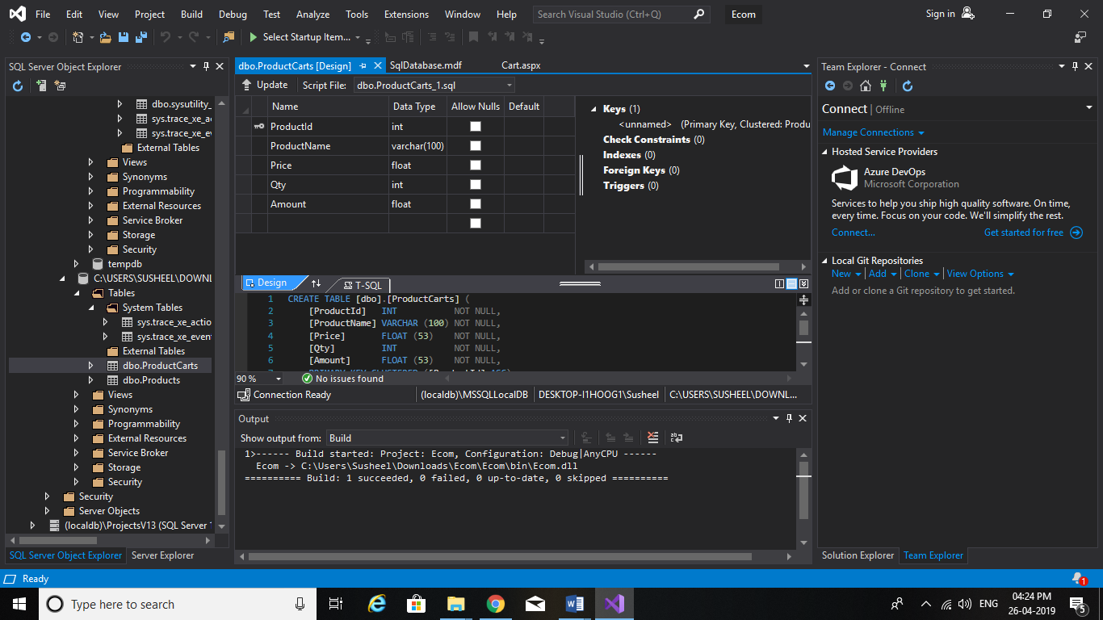

**App Design**

**A screenshot of a cell phone

Description generated with very high confidence A screenshot of a cell phone

Description generated with very high confidence**

**A screenshot of a cell phone

Description generated with very high confidence A screenshot of a cell phone

Description generated with very high confidence**

**Client’s Feedback**

**A screenshot of a computer

Description generated with very high confidence A screenshot of a cell phone

Description generated with very high confidence**

**A screenshot of a cell phone

Description generated with very high confidence**